Task 11: Phishing Attack Simulation & Detection

Tool Used
GoPhish (Kali Linux)
Mailtrap (SMTP Testing)

Objective
To understand phishing attacks by performing a controlled phishing simulation and analyzing detection techniques, user behavior, and prevention methods.

Working & Steps
- Studied phishing attack concepts and social engineering techniques.
- Configured GoPhish on Kali Linux.
- Created a phishing email template.
- Configured a fake landing page for credential capture.
- Used Mailtrap as a safe SMTP testing service.
- Launched a phishing campaign using test email accounts.
- Tracked email delivery, link clicks, and credential submissions.
- Reviewed campaign analytics and user interaction results.
- Documented phishing indicators and prevention strategies.
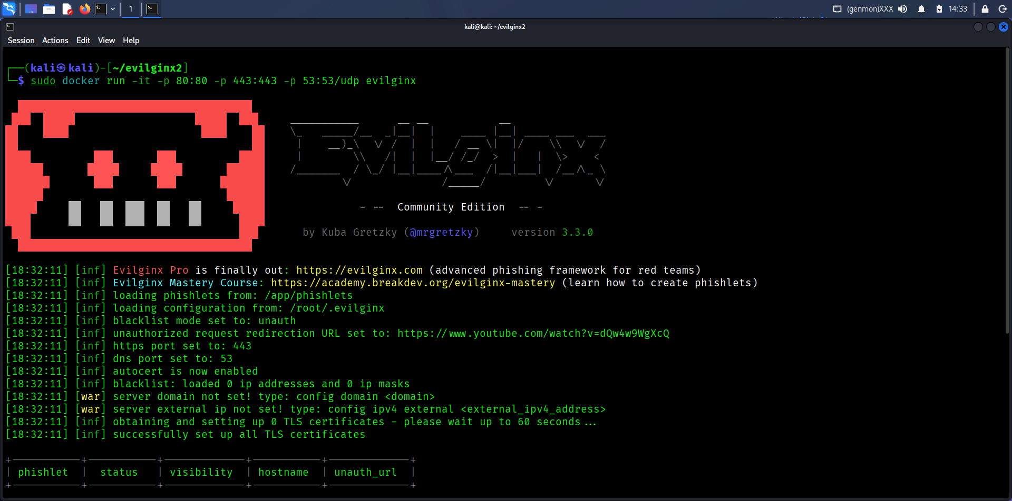
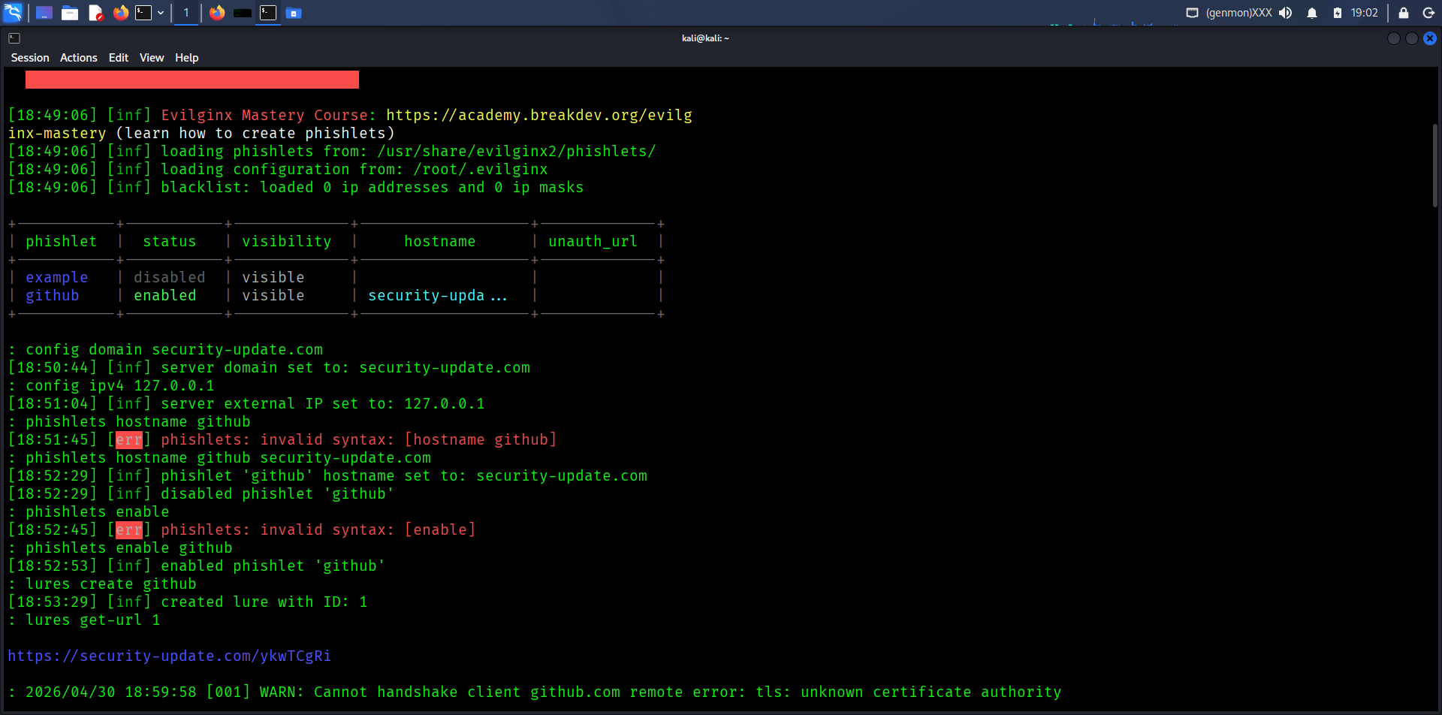
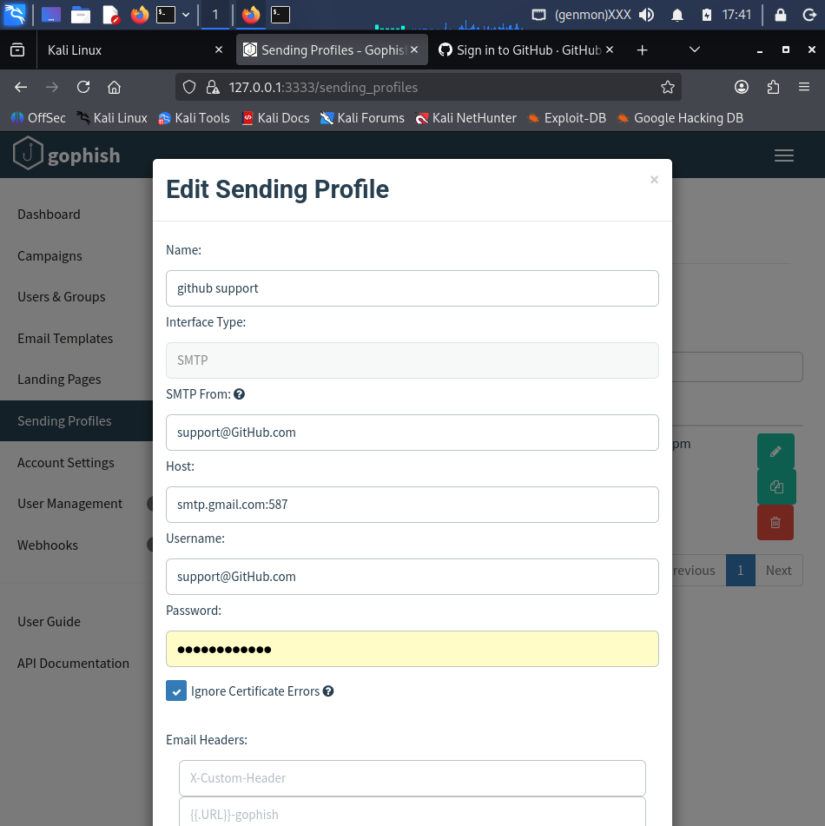

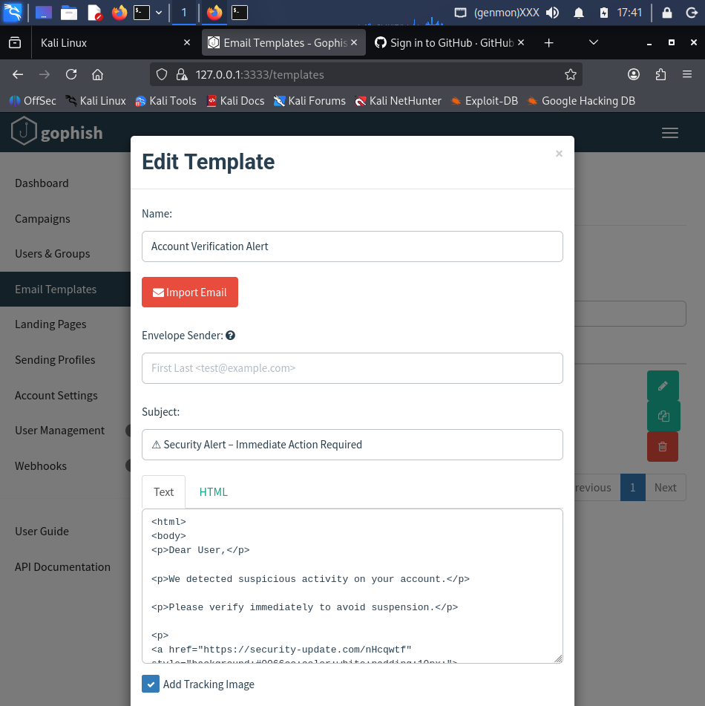

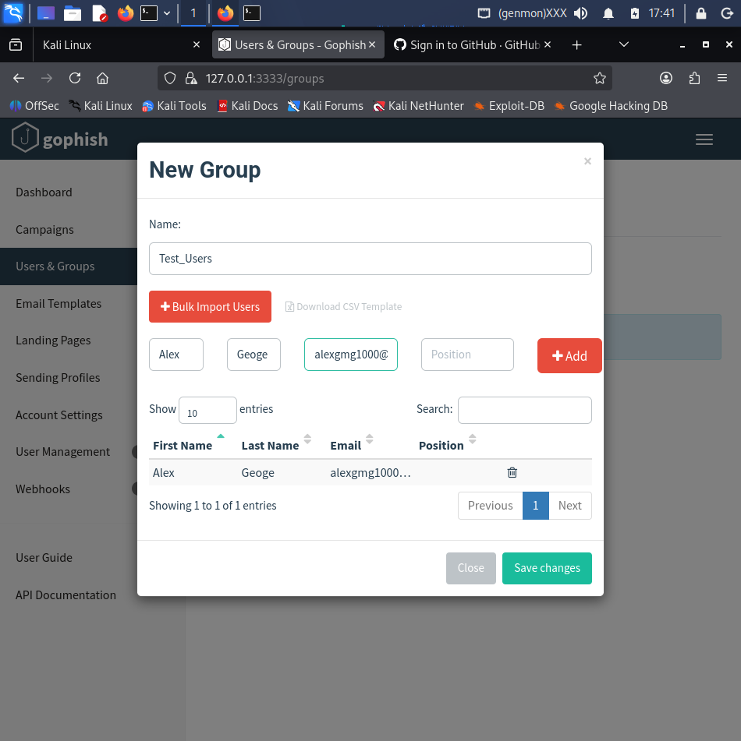

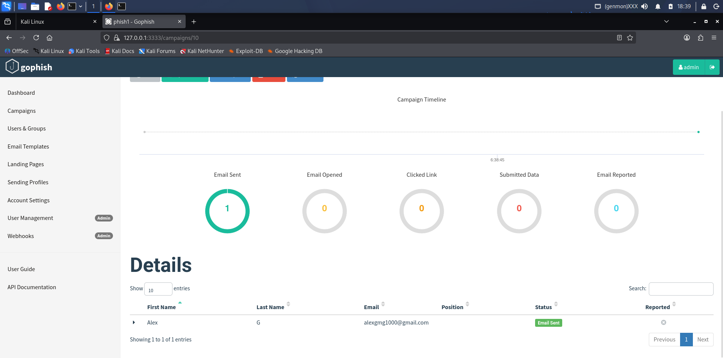

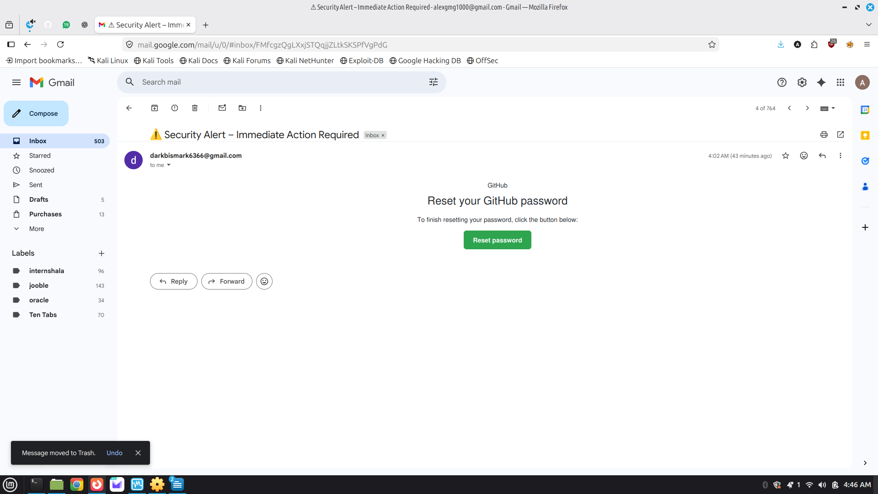

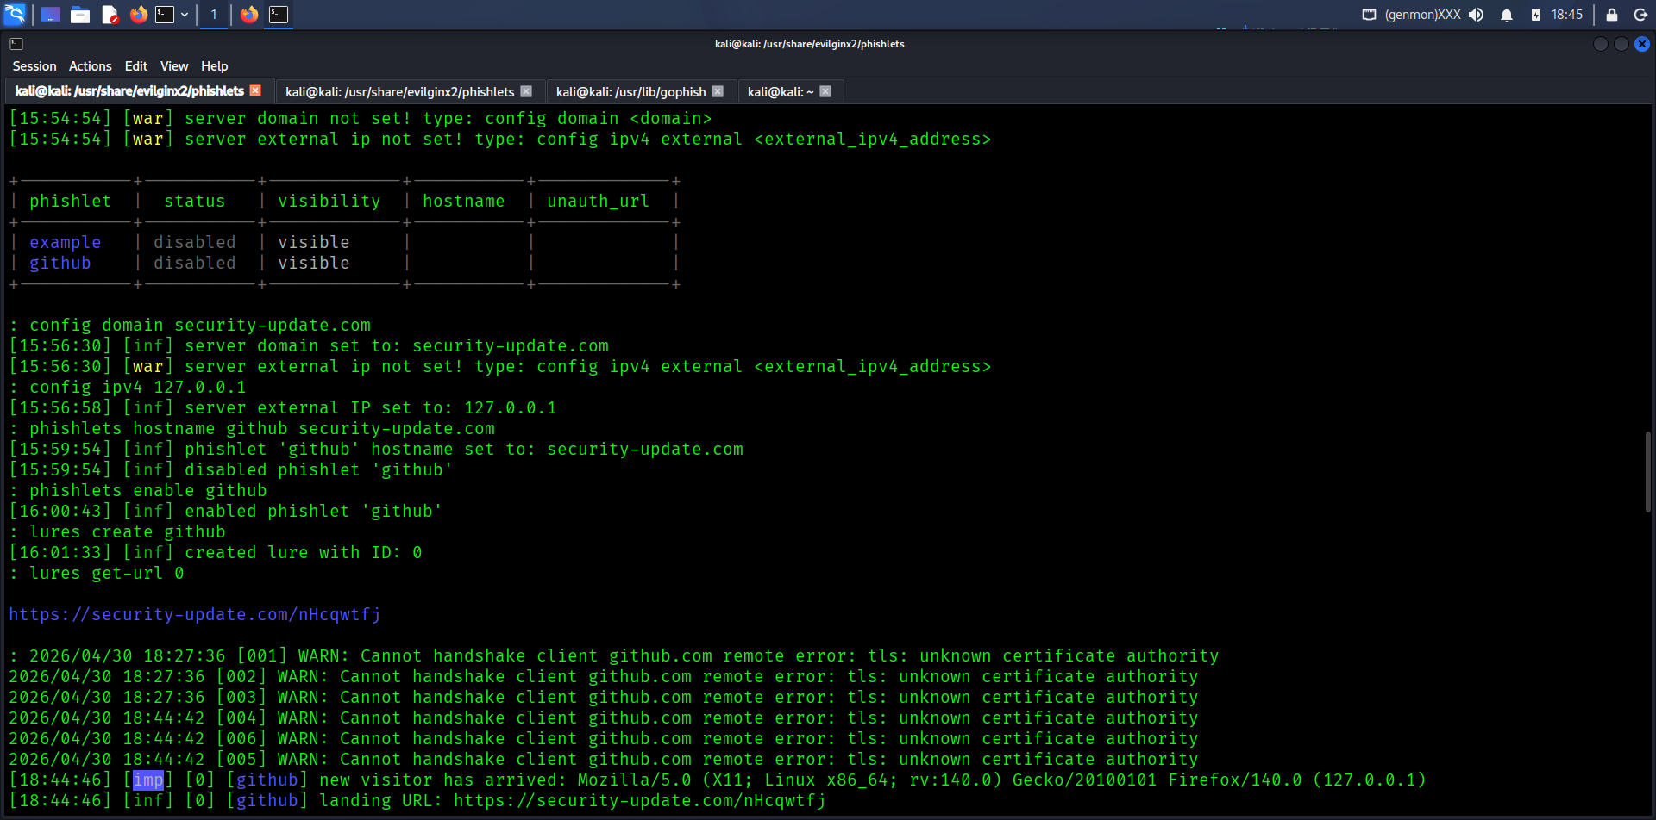

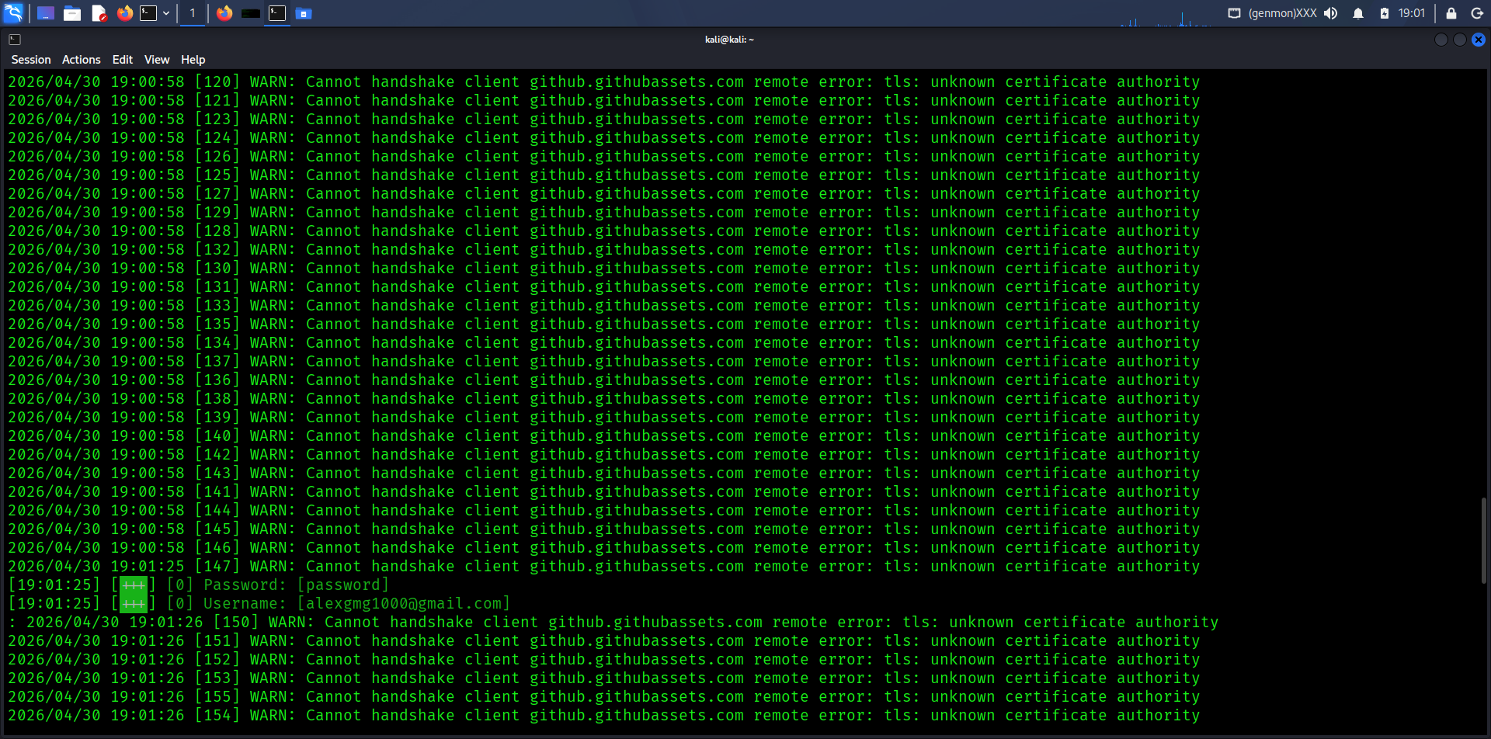

Phishing Red Flags
- Urgent or threatening language
- Generic greetings
- Suspicious links
- Requests for credentials
- Unknown sender

Prevention Methods
- User awareness training
- Email filtering
- Verify sender address
- Hover before clicking links
- Multi-factor authentication (MFA)
- Report phishing emails

Final Outcome
Improved understanding of phishing attacks and enhanced awareness of social engineering techniques and prevention methods.

